Administration av unix-lika system, Lab 3

# 4.1 Bootprocess

## 4.1.1 Grub



## En bild som visar text, skärmbild, Teckensnitt, dokument Automatiskt genererad beskrivning4.1.2 Runlevels

Startar denna vy.

* The links in /etc/rc?.d (range from 0-6, so for example /etc/rc4.d) to are symbolic links to scripts in /etc/init.d. They define which services start or stop in specific runlevels.

# 4.2 File System

I encountered a lot of errors here. These errors came about since when I created my ubuntu I never manually partitioned /dev/sda and instead automatically just installed everything. This led me to many errors on particularly 4 and later. I fixed this by adding a vdi from the virtualbox options.

1. En bild som visar text, skärmbild, Teckensnitt

   Automatiskt genererad beskrivningDisk partition and free space: df, or use lsblk.

I took the screenshot after I did 4-9 because of my errors, that’s why /dev/sdb1 is there and is mounted on /dump.

1. df -h, human readable.

1. Desktop space, its high because I have a project containing large files from another course. If I move the files its around 4,0 k. Well, I crashed my first ubuntu I used for the lab so second screenshot is from the new ubuntu.

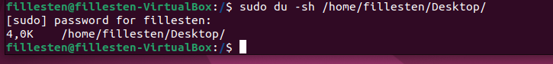

1. En bild som visar text, skärmbild, programvara, Multimedieprogram

   Automatiskt genererad beskrivningCrashed the system multiple times. I have crashed a lot of ubuntus now and all old screenshots of me doing 4.2, 4-9 are in either appendix A or B. I have given up on trying to show them in the right order, but all my work with failing filesystems and partitions are there.  
   Trying this now:

Added an additional new hard disk drive, from the virtualbox options.  
Here we see that I have 0 unpartitiononed space on my original harddrive.

Sudo fdisk -l, to get this screenshot

**Now for the actual partitioning…**

1. /dev/sda4: clean, shows file system is ok.

1. See 8.
2. En bild som visar text, skärmbild, programvara

   Automatiskt genererad beskrivningNew mountpoint and mount new partition to /dump
3. fstab configuration.



* See 2.
* See 3.
* See 4 and 5.
* See 9.
* Used the format they provided in comment.

<file system> = the newly created file system, /dev/sda4  
<mount point> = the newly created mount point, /dump   
<type> = type of file system, I used ext4  
<options> I used default, defaults  
<dump> 0 means to not automatically backed up  
<pass> order to be checked during boot. 1 means first.

## 4.2.1 File-types and Links

1. En bild som visar text, skärmbild, Teckensnitt

   Automatiskt genererad beskrivningFile:

dev folder:

file in etc/init.d:

etc/passwd file:

1. En bild som visar text, skärmbild, Teckensnitt

   Automatiskt genererad beskrivningEn bild som visar text, skärmbild, Teckensnitt

   Automatiskt genererad beskrivningLink within same file system

link outside file system

1. En bild som visar text, skärmbild, Teckensnitt

   Automatiskt genererad beskrivningSame File system:

Other file system:

* Inodes contain: File size, file permissions, user and group ownership, timstamps (birth, change and access), number of hard links, file type and other meta data. They are a reference to the actual data blocks that store the file content.
* What where the difference between the different files you were running stat(1) on?

The difference between the files were: size, permissions, filetype, timestamps (birth, change and access) and the inode number.

* Theoretical discuss hard and soft links
  + Hard Link: A hard link is a reference to an inode in a file system. It creates multiple directory entries (file names) that point to the same inode. All hard links to the same inode are essentially the same file, and changes to one hard link are reflected in all others. Hard links do not have a separate data block and do not contain a path to the target file; they directly reference the inode. You also cannot create a hard link to an outside file system.
  + Symbolic Link: A symbolic link is a separate file that contains a path or URL pointing to the target file or directory. Symbolic links are essentially pointers or shortcuts to other files or directories. They can span across different file systems and even point to non-existent targets.

I think of the difference between the links like references in C++ (because they pretty much are the same). A hard link in unix is a like a reference in C++ so if a function with inparameter int x is called with int y and x is taken as a reference any changes to x inside the function gets applied y.

* Practical difference:
  + Hard Link: Changes made to the target file are immediately reflected in all hard links because they all point to the same inode. Hard links are useful for creating multiple references to the same data without duplicating storage.
  + Soft Link: Symbolic links are separate files that reference the target file by its path. If the target file is moved or deleted, the symbolic link becomes broken and points to a non-existent target. Symbolic links provide flexibility to link to files in different locations and even across file systems.
* Different usage scenarios:
  + Hard Links: Hard links are commonly used for creating backups, version control systems, and when you want multiple directory entries to refer to the same physical data. They save storage space because the data is shared.
  + Symbolic Links: Symbolic links are useful for creating references to files or directories in different locations, like linking configuration files, providing easy access to frequently used files, and creating cross-file system references. They offer more flexibility and are often used in situations where the target may change or is not always available.

# 4.3 Users, Groups and Permissions

## 4.3.1 User and Groups

1. 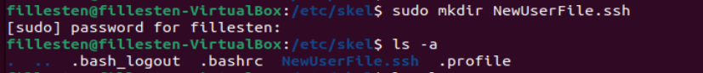Donald worked fine.

However for mickey I accidentally messed something up so had to remove some stuff and started over.

* Explain UID and GID: See the last image of 3.
  + Each user has their own UID, and this UID is used for various operations related to file permissions, process ownership, and more.
  + Users can belong to one or more groups, and each group has its own GID. Group memberships can determine access rights to shared resources.
* Inside /etc/skel I created a new folder called NewUserFile.ssh. When creating a new user all information from etc/skel is used.
* To create new users, I have to be root or use sudo. I do it by running the command adduser <new_username>. Then I fill in the additional information like name, phone, password etc about the new user. I created the group Disney with sudo which just finishes as you enter the command, however to add users to a group you similarly need the root or sudo privileges.
* 3 screenshots (below) which contain info from passwd: 1 is command and some output, 2 only output, 3 last output and 3 users, fillesten, Donald and mickey!

## 4.3.2 Permissions

1. En bild som visar text, skärmbild, Teckensnitt

   Automatiskt genererad beskrivning
2. En bild som visar text, skärmbild, Teckensnitt

   Automatiskt genererad beskrivningBefore change

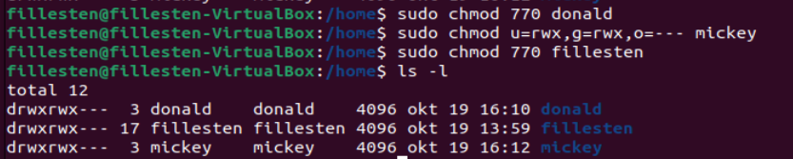After change

1. En bild som visar text, skärmbild, Teckensnitt

   Automatiskt genererad beskrivning

* See task 3.
* Explaining the image below:

**-rw-r--r--:** are the permissions, owner has read and write, group read only, others read only  
**1:** number of hard links to the file.  
**lennart lennart:** first lennart is owner of file, second lennart is group that owns file  
**5496:** the size of the file in bytes  
**nov 10 17:40:** timestamp of latest modification  
**lab_assgn2.tex**: file name

# 4.4 Backup and File Copy

The cp script. This script uses the cp command to recursively (-R) copy the contents of my home folder to my backup location.

The tar script. /home is source of files, /dump/… is destination  
-c, creates an archive by bundling files and directories together.   
-z, uses gzip compression when creating a tar file, resulting in a compressed archive with the ‘.tar.gz’ extension.  
-v, displays verbose information, providing detailed output during the archiving or extraction process.  
-f, specifies the filename of the archive to be created or extracted.

The cpio script. Copy in/out. The command copies files to and from archives. It uses find to find all regular files and subdirectories with -depth and lastly prints their name. This is then piped into cpio.  
-p, preserve file structure  
-v, makes cpio display information about the files being copied  
-d, makes cpio create directories as necessary

The rsync script. Rsync is used for synchronizing files and directories between two locations.  
-a, archive, is a combination of multiple flags. It preserves file attributes like permissions, timestamps and others.  
-v, verbose, this flag makes rsync display detailed information about the files being copied.  
home is source directory, dump/rsyncbackup is destination directory

# 4.5 Sharing Files

## 4.5.1 File Transfer Protocol

1. ftp server running.

1. Inside etc/vsftpd.conf I have to uncomment the chroot_local_user=YES

## En bild som visar text, skärmbild, Teckensnitt Automatiskt genererad beskrivning4.5.2 Network File System

Install the nfs server package

Make directories for sharing



Change permissions on directories.  
Public: Everyone can read and execute but owner can also write  
Private: everyone can read, write, execute.  


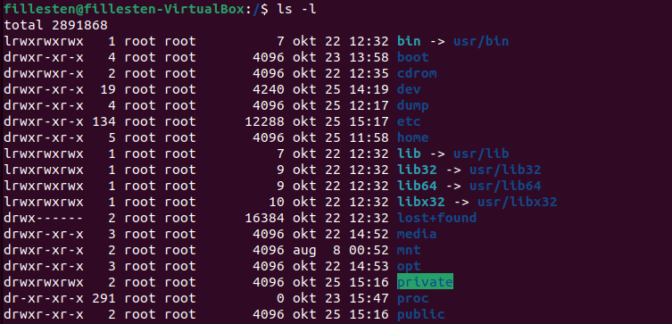

Ip address: 10.0.2.15  
subnet mask /24 = 255.255.255.0.  
so inside etc/exports.

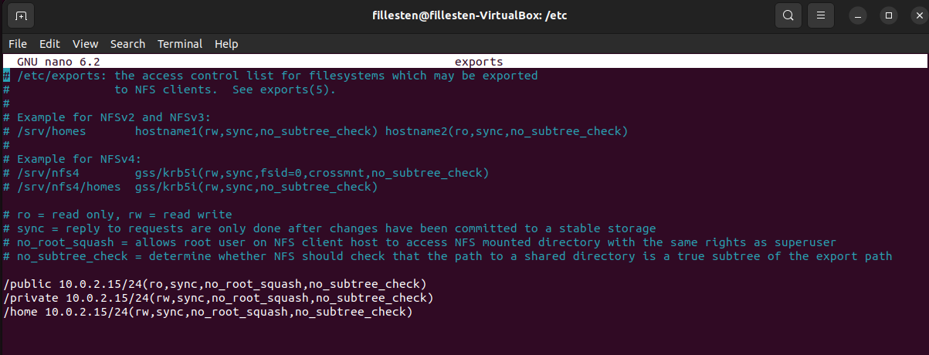



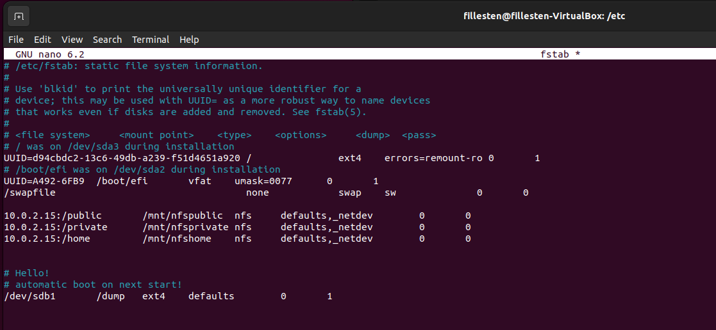

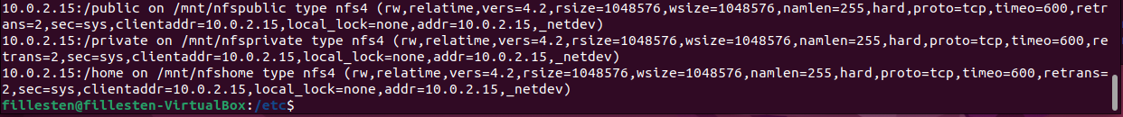



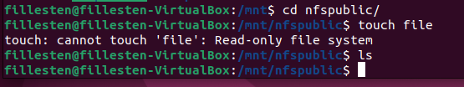

NFS proof:

Here i remove the testfile, in /private, then I check for any files and see 0 files. Then I move over to mnt/nfsprivate and create a file there. Navigates back to /private and check if there is a file. There is a file in /private, the nfs works!

## 4.5.3 Samba – A windows SMB / CIFS file server for UNIX





Password is 1234, for myself to remember.Samba proof:

So by just updating or clicking another file destination in the file thing , I clicked Home and then back the file is now there.

* Follow the steps I took in 4.5.1, 4.5.2 and 4.5.3.
  + FTP: I had to uncomment chroot_local_user=YES.
  + NFS I had to find my ip address and then set up the server accordingly.
  + Samba was easiest, the trickiest part of it was to add it to the file application. With smb://<ip_address>/<createddirectory>
* File permissions:
  + FTP: one can use the vsftpd.conf file to manage permissions
  + NFS: utilizing the exports file and make restrictions in different folders there
  + Samba: same as FTP.
* Screenshots of working FTP, NFS and Samba are in in 4.5.1, 4.5.2 and 4.5.3 respectively.

# En bild som visar text, skärmbild, Teckensnitt Automatiskt genererad beskrivningAppendix A: The appendices are not a part of the solution to the lab. messing up with sda4:

# Appendix B: Second failed attempt at partitioning.

